

Day 1

Ramaswamy P

InNOVATIVE iNTELLIGENT sOLUTIONS

Version 1.0

HTML Exercise

Formats

Note to students:

1. Must complete these exercise before next session
2. Upload the code in GitHub action

Estimated hours to complete: 2 Hours

**Exercise 1: Runner Home**

* Write an HTML page like the following:

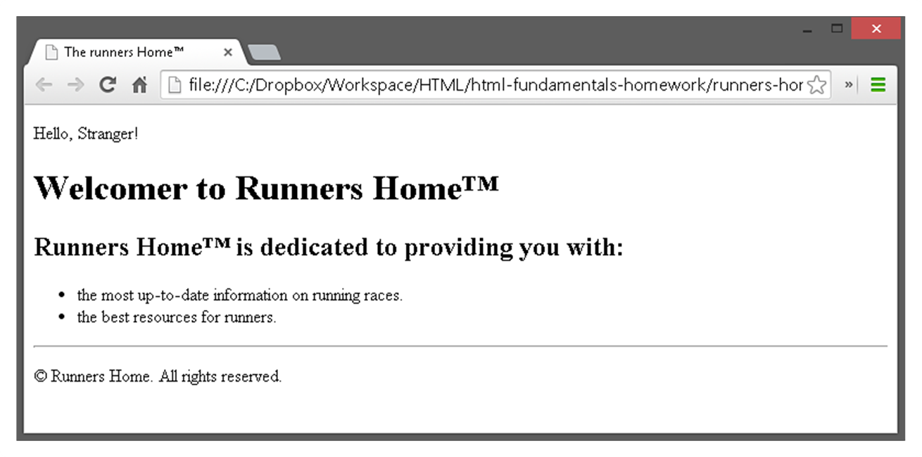

**Exercise 2: Nested Lists**

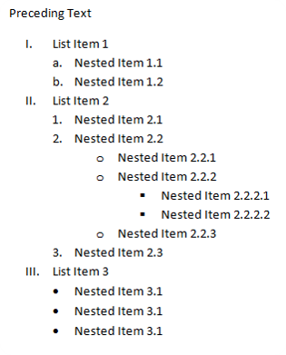

**Exercise 3: Social site**

* Create an user profile Web page profile.html, friends page named friends.html and info page named home.html.
* Link them to one another using <a> tag

[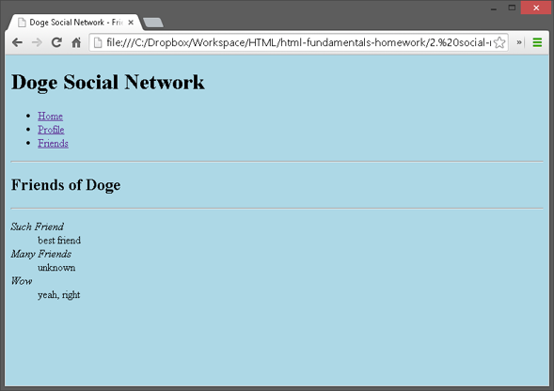](https://cloud.githubusercontent.com/assets/3619393/7002582/b53708fc-dc55-11e4-88f9-831a63a7a6c0.png)

[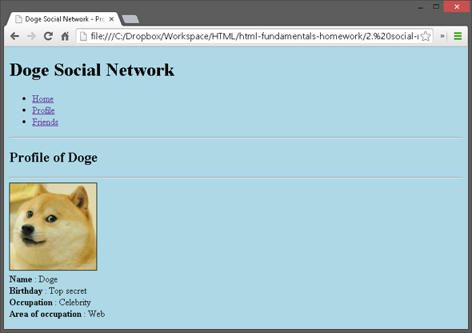](https://cloud.githubusercontent.com/assets/3619393/7002592/c14ee27c-dc55-11e4-85c5-42fefe9f9751.png)

[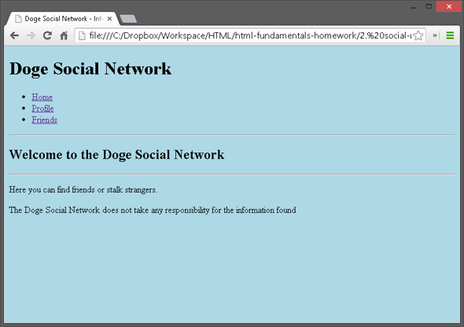](https://cloud.githubusercontent.com/assets/3619393/7002594/c9f92266-dc55-11e4-8396-f5ac08234561.png)

Exercise: 3

